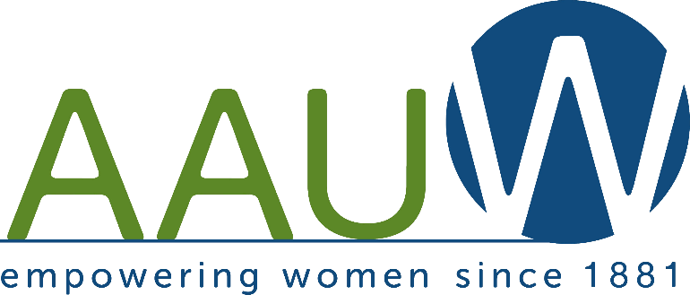
American Association of University Women
Rockford Area Affiliate STEM Scholarship

http://rockfordarea-il.aauw.net/

Award Application
Deadline: April 1, 2022

Rules for Eligibility -- Candidates must:
- Be a female resident of Winnebago, Boone or Ogle County.
- Be an enrolled senior at a Winnebago, Boone or Ogle County public or private high school.
- Have a minimum GPA of 3.5 out of 4.0.
- Have a chosen academic field of study in Science, Technology, Engineering, or Math (STEM) as listed at
https://www.onetonline.org/find/stem/?t=0
Applications without an identified STEM major from female underrepresented careers (such as Nursing) will not be considered.
- Fulfill all requirements of the application process.
INCOMPLETE APPLICATIONS WILL NOT BE CONSIDERED.

CRITERIA FOR AWARD RECIPIENT SELECTION:
- Academic achievements which indicate a high potential for success in post-secondary education (includes review of transcripts, ACT/SAT scores, scholastic achievements and awards).
- Strength of essay written for application and focus on applicant’s interest in STEM. (Limit of two pages with a legible font no smaller than 10pt, double spaced)
- Submission of at least two letters of recommendation (three or four are encouraged). At least one of the letters must be written by at least one STEM teacher.
- Level of involvement in school and community activities and/or employment that indicates engagement and leadership.
- Classification as a graduating senior by the time the award is granted followed by proof of course registration at an accredited college or university for the 2022-2023 academic year.

EXPECTATION:
Scholarship winners will be expected to submit a suitable photo and give brief remarks at the award meeting, mid morning, on Saturday May 21 2022.

PROCEDURES:
- It is recommended that candidates work closely with their school counselors while processing this application. A final signature from a high school counselor is required.
- All parts of this application must be readable. Electronic submission is strongly preferred, email to aauwrockford@gmail.com.
- The scholarship committee will review all eligible applications. Candidates will be scored based on the quality of the overall application. Incomplete applications will not be considered.

Four $1000 scholarships from AAUW will be awarded.
Awardees will be notified by April 22, 2022.

Please mail or deliver all application documents to one of the following addresses.
Email address: aauwrockford@gmail.com
Mailing address: Rockford Area Branch AAUW
℅ Rockford YWCA
4990 E. State St.
Rockford, IL 61108

APPLICATION DEADLINE: April 1, 2022
American Association of University Women STEM SCHOLARSHIP APPLICATION

Student’s First Name Middle Name Last Name

Street Address City State Zip Email

Best phone # to reach you Date of Birth: Month/Day/Year

Father’s Full Name Phone Number

Mother’s Full Name Phone Number

Anticipated Graduation Date: GPA ACT/SAT Score

High School (Full Name):

High School Counselor: Telephone #:

Check STEM areas you will be studying: _____ Science _____ Technology _____ Engineering _____ Math

I have applied for admittance in the fall to the following colleges or universities:
_____________________________________________________________________________________________

My academic major will be: _______________________________________________________________________

How did you find out about this scholarship?
_____________________________________________________________________________________________

Applicant’s Full Signature Date

High School Counselor’s Signature Date

Attach the following documents:
- Official High School Transcript, complete with ACT or SAT score
- Biographical Essay (must be typed)
Focus the biographical essay on your STEM interest and future goals upon completing college. (Limit of two pages with a legible font no smaller than 10pt, double spaced)
- At least two letters of recommendation. One of the letters must be written by a STEM teacher.
- Extra-Curricular School Activities and Achievements, Community Volunteerism and/or Employment
  - List extra-curricular activities at school and the year of participation.
  - List leadership positions in school and the year of service.
  - List earned honors or awards and the year received.
  - List volunteer service to community (church, cultural and civic organizations, etc.)
  - List leadership position(s) in the community or earned recognition
  - Employment information (list employer, job title, number of weekly hours)
SIGN THE FOLLOWING AGREEMENT

If selected, I agree to submit a suitable photo which may be used with my biographical information for media coverage of the awards ceremony and also promotion of the scholarship fund. I understand that scholarship recipients will be required to attend and give brief remarks at the awards meeting on Saturday May 21, 2022.

__________________________________________________
Student’s Signature

This application and all required documents must be received April 1, 2022.

